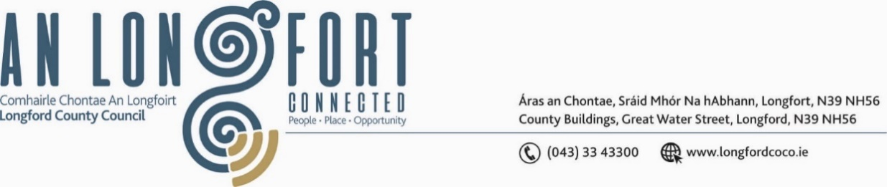

***Meeting to be held in the Council Chamber and on Microsoft Teams***

**21ú Meitheamh 2023.**

**Chuig: Gach Ball don Chomhairle.**

A Chomhairleoir,

Iarrtar ort bheith i láthair ag Cruinniú Ginearálta Bliantúil Chomhairle Chontae Longfoirt a tionólfar i Seomra na Comhairle, Aras an Chontae, Longfoirt nó ar Microsoft Teams, Déardaoin, 29ú Meitheamh 2023 ag 4.00i.n. chun gnó a dhéanamh mar atá leagtha amach ar an gClár Oibre faoi seo.

You are requested to attend the Annual Meeting of Longford County Council to be held in the **Council Chamber, Aras an Chontae,** **Longford and on Microsoft Teams** on **Thursday 29 June 2023 at 4pm** to transact business, as set out on the Agenda hereunder.

Mise le meas,

_______________

**Claire McNabola,**

**Meetings Administrator.**

**C L Á R**

Prayer before Meeting.

**1.** Election of Cathaoirleach

**2.** Election of Leas Cathaoirleach